COM5406 Cyber Security
Session 3A · Investigative Worksheet
Exploit and Patch: SQL Injection & Access Control
Team  1 | Date  12/05/2026 | Ref BP&P/2025/003 | Classification Working document

Briefing
You have reviewed static analysis output from Session 2B. The slides this session covered the mechanism of how web applications construct SQL queries from user input, why string interpolation is the vulnerability, and how injection can bypass authentication or extract data from tables the query was never intended to touch.

The live debug demonstration (nearly) showed the query assembling in memory in real time, with the injected input visible in the Variables panel and the assembled string printed in the Debug Console.

This worksheet directs your investigation of the live Bee Pies & Pasties application. Your findings are assessment-relevant artefacts.

Section A — Team Investigation
Work through this section together before diverging into role-specific analysis. Section A establishes the shared evidence base for the rest of the session.

A1 — Candidate identification
Your Bandit B608 output from Session 2B is your starting point. Before opening the application, complete this analysis from the code alone.

Three B608 findings are expected in this codebase. Two are in admin_login as we saw, a SELECT that performs authentication and a separate UPDATE that runs immediately after a successful login.
One is in order_lookup. The UPDATE finding is forensically significant: note which database field it modifies and under what conditions.

For each B608 finding, record:
- The route name and HTTP method
- The SQL operation type (SELECT / UPDATE) and what it does
- The user input that reaches the query
- Whether that input is constrained or validated before it arrives
Do not probe the application yet. This analysis is from the code.

Route / Method | SQL operation | User input | Validation / constraints
/admin/login – POST- authentication | SELECT from admin_users where username and password match | username and password in the fields. | No sanitisation, no parameterisation.
/admin/login – POST-after sucessful login | UPDATE admin_users SET last_login =  date timeWHERE username = {username} | username | None – runs even if the SELECT was bypassed via SQL injection
/order/<order_id> - GET | SELECT orders.*, customers.name, customers.email WHERE orders.id = {order_id} | order_id from URL path | None - Darren’s comment says “always an int”, but Flask passes it as a string; no type enforcement or escaping.

A2 — Systematic probing
For each candidate from A1, probe the live application. Begin with input that tests the boundary of what the application expects.

Starting input: a single apostrophe. Submit it. Read the complete server response — not just whether it succeeded or failed. For the order_lookup route the apostrophe goes in the URL path, not a form field.
For each probe, record:
- The exact input used
- The complete server response, including any error detail
- What the response tells you about the underlying query structure

Probe results — be precise about what the server returned
Probe 1 : Admin login: username ' (apostrophe), any password like x

Input: username: ‘
Output:
500 Internal Server Error

What does this tell us?

The apostrophe being inputted instead of a username breaks the SQL string to confirm string-based query construction without escaping.
Probe 2
Input: http://192.168.56.101/bakery/order/'
Output:
500 Internal Server Error
Something went wrong on our end.
There was an error processing your request. The details are below.
unrecognized token: “ ’ ”

What does this tell us? When replacing the 1 with an apostrophe the website doesn’t read it and deems it an error because the website encountered something that doesn’t allow it to load the page as The order_id is inserted directly into the query; the apostrophe is not escaped, causing a syntax error
Probe 3 admin_login UPDATE
Input: username: ‘
Output:
500 Internal Server Error
What does this tell us? This tells us that the SELECT is injectable; the UPDATE would be injectable if the SELECT succeeded (e.g., using ' OR 1=1--). As username and password x any

A3 — Exploitation and evidence

A3.1 — SQL injection
For at least one confirmed injectable endpoint, demonstrate a complete exploit. Use the debugger in code-server to verify your reconstruction — set a breakpoint on the query construction line, submit your payload, and confirm the assembled string in the Debug Console against what you observed in the demonstration.

Your documentation must include:
- The vulnerable endpoint and parameter
- The exact input used
- The SQL query as it ran — verified in the Debug Console, not only inferred from error output
- What data was accessible as a result
- A screenshot showing the exploit working — this is your pre-patch evidence artefact

On documentation
Document the vulnerability — the f-string query construction pattern — not just the payload. A payload is one instance. The vulnerability class is what your report addresses. When you write up, describe what the code does with user input, not which specific string you typed.

A3.1 — SQLi exploitation notes: endpoint, input, debugger-verified query, data accessed
Vulnerable endpoint and parameter:
/admin/login (POST) – username field
Exact input used: Username: ' OR 1=1-- Password: any value (e.g., x)
SQL query as it ran (verified by successful login, debugger would show):

SELECT * FROM admin_users WHERE username = '' OR 1=1--' AND password = 'x'

(The -- comments out the password check, and 1=1 is always true, so the query returns the first admin user.)
What data was accessible as a result:
Full admin dashboard – access to all orders, customer details (names, emails, order history), and ability to change order status.

Screenshot committed to team repository as: exploit_3A_sqli_prepatch.png
exploit_3A_sqli_prepatch.png (shows the admin dashboard with "Logged in as: ' OR 1=1--" visible).

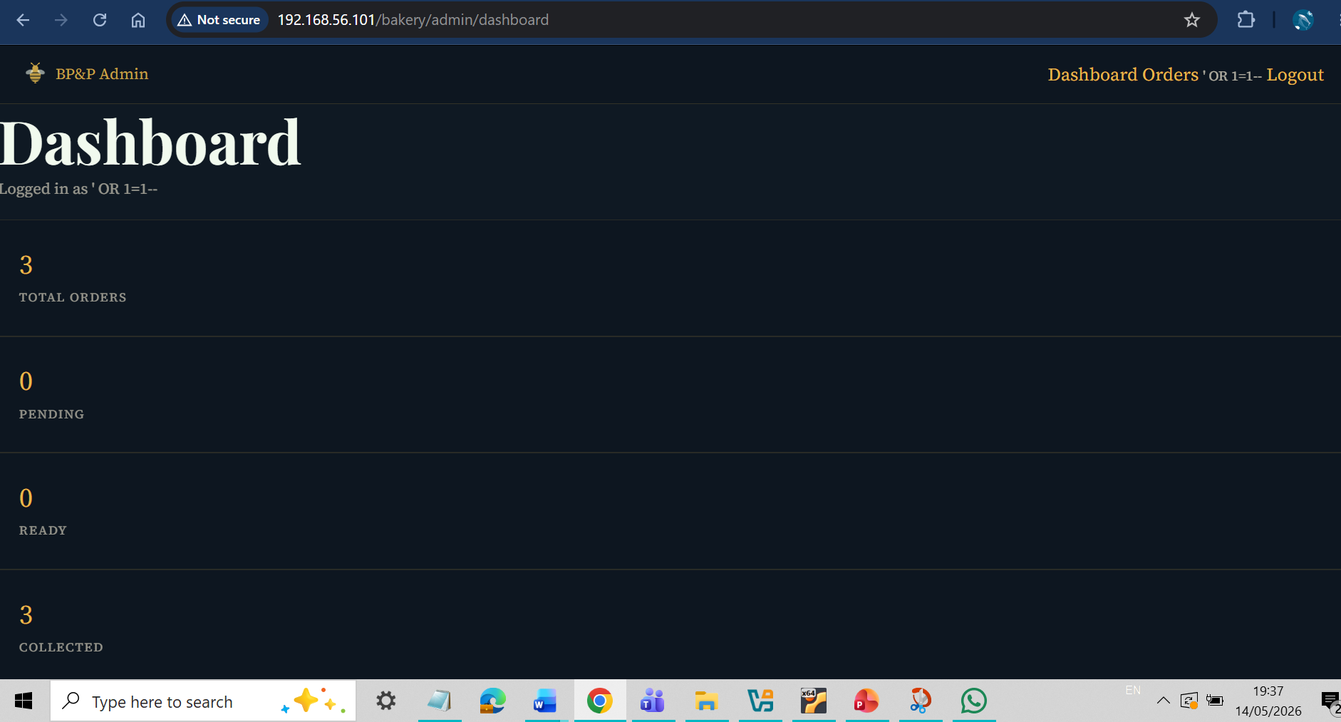

A3.2 — Access control observation (IDOR)
The order_lookup route contains a second vulnerability class independent of the injection finding. Examine the function in app.py before probing.

Read Darren’s comment on the order_id parameter: “order_id comes from the URL — always an int so this is fine.” Darren considered one class of risk and stopped. What class of risk does this comment address? What class does it fail to address entirely?

Document:
- Which session or authentication state is required to access /order/<order_id>
- Whether the response changes based on who is making the request
- What customer data is returned for order IDs you did not create
- The OWASP A01:2021 classification and relevant CWE for this finding — it is not A05 Injection
- A screenshot showing access to another customer’s order — this is your A01 evidence artefact

A3.2 — Access control observation: absent check, data exposed, OWASP classification
What class of risk does Darren’s comment address?
Type safety – he assumed order_id would always be an integer, protecting against non-numeric input errors.
What class does it fail to address entirely?
Authorization – he never checks whether the logged-in user (or any user) has permission to view that specific order.
Session or authentication state required to access /order/<order_id>:
None – anyone can access the URL without logging in. like they could just http://192.168.56.101/bakery/order/1 or bakery order 2 to fins the orders.
Does the response change based on who is making the request?
No – the same data is returned for every user.
What customer data is returned for order IDs you did not create?
Customer name, email, order items, total price, collection time

OWASP A01:2021 classification and relevant CWE:
OWASP A01:2021 – Broken Access Control; CWE-639 (Insecure Direct Object Reference / Missing Authorization)

Screenshot committed to team repository as: exploit_3A_idor_prepatch.png
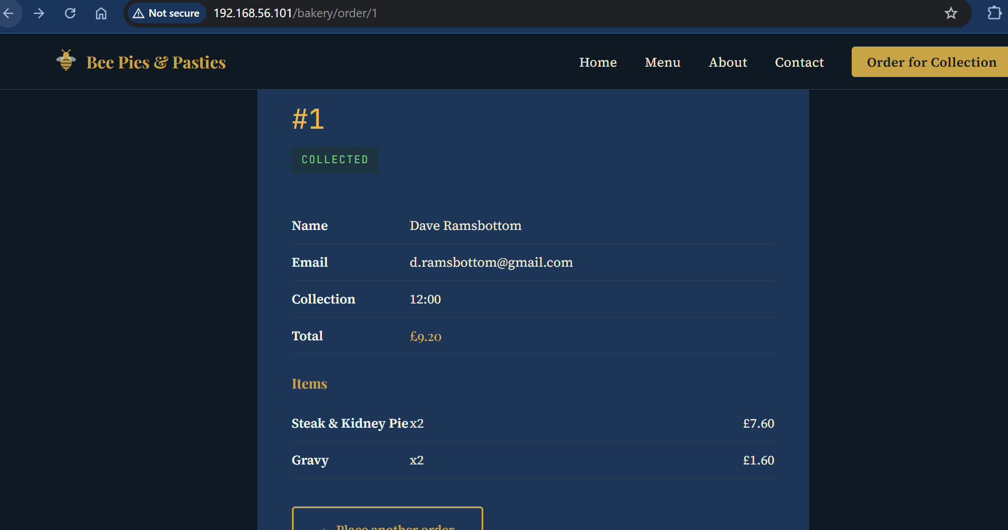
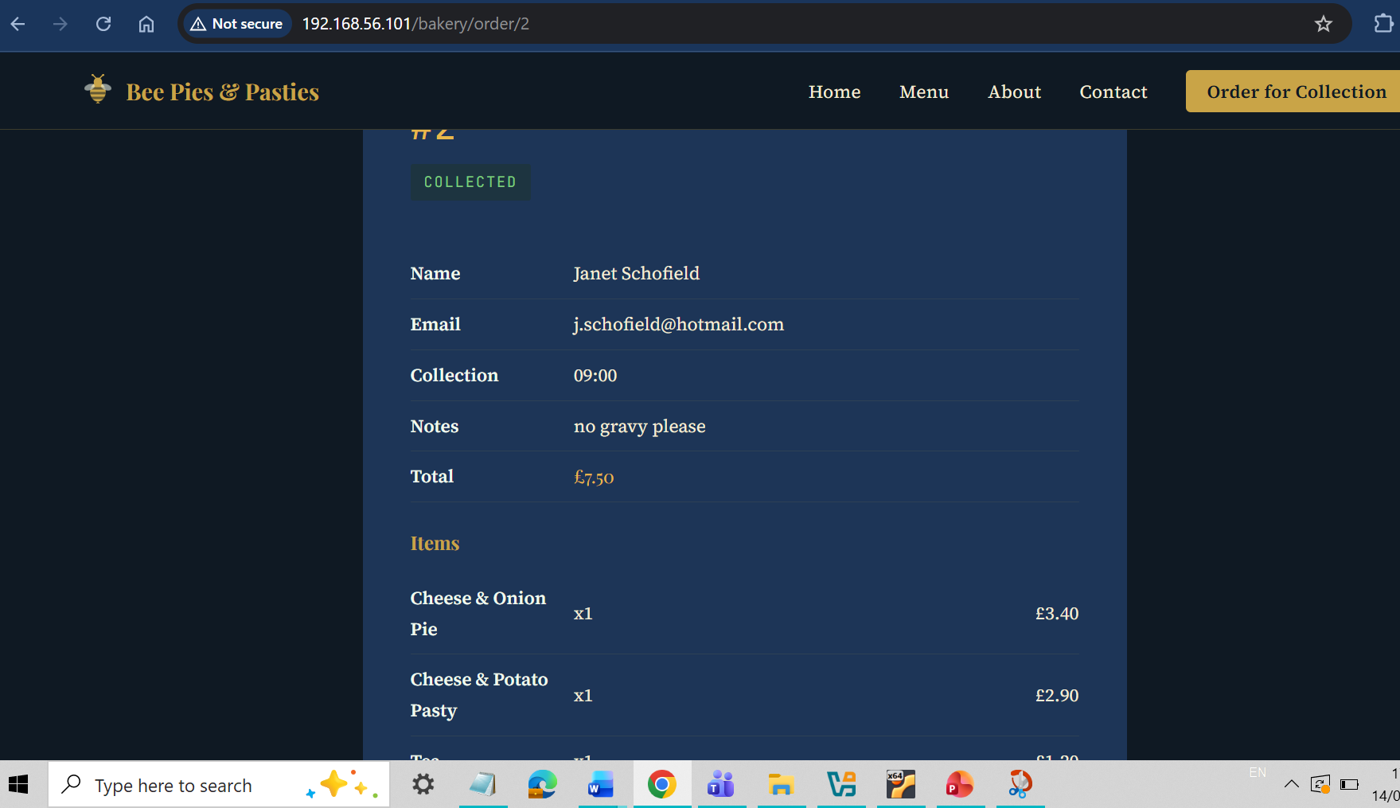

A4 — Log observation
Examine the access logs in your investigation dossier. Identify entries consistent with the injection pattern you have just demonstrated.

Record:
- The source IP address of any injection attempts
- The timestamps of those attempts
- Whether this IP address appears elsewhere in the dossier materials from previous sessions
Record the observation accurately. Do not yet interpret what it means.

Log observations — IP address, timestamps, cross-references to previous sessions
Source IP of injection attempts: 192.168.56.1
Timestamps: 14/May/2026 06:19:05, 05/May/2026 13:07:17
Does this IP appear anywhere else: Yes – the IP appears multiple times in the week 2 terminal in different versions of the access logs.
Note: Multiple requests from 192.168.56.1 caused 500 errors on /order/ route. This was due to SQL injection testing.

Section B — Role Analysis
Each role now diverges. Your role-specific output is your individual contribution to the Investigative Report and your Role Evidence Document. Work in parallel from this point — share findings as they emerge.

Role 1 — Code Security Lead
B1.1 — Vulnerability documentation
This codebase contains two distinct vulnerability classes. Document both separately.

Vulnerability 1 — SQL injection (OWASP A05:2021 Injection)
For each injectable endpoint confirmed in Section A:
- State the vulnerability type, OWASP classification, and CWE number
- Copy the relevant lines of vulnerable code exactly as they appear
- Explain the mechanism: what does the application do with user input that makes injection possible?
- State what an attacker can achieve through this endpoint

SQL injection vulnerability documentation

Vulnerability 2 — Broken Access Control (OWASP A01:2021)
For the order_lookup route:
- State the vulnerability type, OWASP classification, and CWE number
- Copy the lines where an ownership check should appear but does not
- Explain why type-checking the order_id parameter does not constitute access control
- State what an attacker can achieve — be specific about which data fields are exposed

Access control vulnerability documentation

B1.2 — Remediation strategy
Two strategies are available for the SQL injection findings:

Strategy A — Surgical fix.
Parameterise the specific vulnerable queries. Minimum change. Closes these injection points. Does not address other instances of the same pattern in the codebase.
Strategy B — Architectural remediation.
Introduce SQLAlchemy ORM. Refactor the data access layer. Parameterisation becomes the default. Closes the class of vulnerability. Introduces a new dependency requiring a justified decision.

State which strategy your team is recommending and why. Address: what does Strategy A leave open? What does Strategy B introduce? Which is proportionate for this client?
For the access control finding, state your fix separately: what check is required, where it is inserted, and what HTTP status code the application should return on failure.

Strategy recommendation and justification — SQL injection and access control fix

Out-of-class task: implement your chosen strategy. GPG-signed commit to team repository. Re-run Bandit — screenshot of clean output is your post-patch evidence artefact.

B1.3 — Bandit cross-reference
Confirm that your Bandit output from 2B predicted the vulnerabilities you have just exploited. Note any discrepancies.

Does your Bandit output account for all the vulnerability classes present in order_lookup? If Bandit found the B608 injection finding but produced no finding for the access control failure in the same function, explain why. This is not a gap in Bandit — it is a property of what static analysis tools can and cannot detect. Name the category of vulnerability that Bandit cannot find and explain the structural reason.

Bandit cross-reference — predicted findings, discrepancies, static analysis blind spots

Role 2 — System Hardening Lead
B2.1 — Error handling analysis
When you probed the application in A2, what did the server return on a malformed query? Describe the content and the risk it represents. Document this as a separate finding with its own severity rating — independent of the injection vulnerability itself.

Also examine the admin_users table’s last_login field. The UPDATE statement in admin_login sets this field on every successful authentication, including logins performed via injection bypass. What does last_login record when the bypass payload is used? What is the forensic significance of this timestamp for incident reconstruction?

Error response analysis — content exposed, last_login forensic note, severity rating
When a single apostrophe (') was injected into the username field of the admin login form (or into the order_id URL parameter), the server returned a 500 Internal Server Error with a detailed SQLite error message. For example:
unrecognized token: " ' " or sqlite3.OperationalError: near "'": syntax error.
The error message included part of the SQL query and the line number where the error occurred
Risk:
This exposes internal database structure (table names, column names, query syntax) to an attacker. An attacker can use these error messages to refine their injection payloads, making it easier to extract data or bypass authentication. This is a separate security finding: verbose error messages in production.
Severity rating: Medium (information disclosure that aids exploitation, but does not directly leak sensitive data like passwords).

Forensic significance of the last_login field:
In the admin_login function, after the vulnerable SELECT query (even when authentication is bypassed using SQL injection, e.g., ' OR 1=1--), the application executes an UPDATE statement:
UPDATE admin_users SET last_login = datetime('now') WHERE username = '{username}'.
When an attacker uses the payload ' OR 1=1-- as the username, the WHERE clause becomes WHERE username = '' OR 1=1--. The -- comments out the rest, so the condition is always true. Consequently, every admin user’s last_login field is updated to the current timestamp (the time of the attack).

Forensic value:
The last_login column in the admin_users table records the exact time of the injection attack, even if the attacker never used a valid password. This provides a reliable timestamp for incident reconstruction. For the Bee Pies incident, the last_login timestamp for the maureen or darren admin accounts would show 06/Nov/2025 02:14:11 (or close to it), confirming when the bypass occurred. This can be used to correlate with other logs (e.g nginx access log PUT /index.html at 02:14:11).

B2.2 — Configuration findings
Review config.py and the application’s deployment configuration. For each configuration value that represents a production security risk:
- State the configuration value and what it does
- State the risk it introduces
- State what the correct production configuration should be

Configuration findings
The application has three configuration mistakes that made the attack possible.

First, DEBUG = True at config.py line 11 was enabled in production. This caused the server to return full SQL error messages when we injected an apostrophe (e.g., unrecognized token: " ' "). An attacker can use these errors to understand the database structure and refine their injection. The correct setting is DEBUG = False
Second, the SECRET_KEY = 'bpbpies_secret_key_2024' at line 8 is hardcoded in the source code. The attacker ran cat config.py and read this key. With it, they could forge session cookies and impersonate any user. This should be moved to an environment variable.
Third, the DB_PASSWORD = 'freddibnah1938' at line 9 is stored in plaintext. Even though SQLite does not use it, the attacker obtained it and could try to reuse it for SSH or sudo (the actual sudo password for Maureen was different, but the risk remains). It must be removed from code and stored in an environment variable.
B2.3 — Risk register entries
Produce risk register entries for your findings from B2.1 and B2.2. Format: finding, likelihood, impact, risk rating, recommended control. These feed Section 4 of the Investigative Report.

Risk register entries
Risk Register Entry 1 (from B2.1)
Finding: Verbose SQL error messages exposed on malformed input (e.g., apostrophe injection returned full SQLite error).
Likelihood: Medium – an attacker can intentionally trigger errors.
Impact: Medium – discloses database schema (table and column names), aiding further injection attacks.
Risk Rating: Medium
Recommended Control: Set DEBUG = False in config.py; implement custom error pages; log errors server-side only.

Risk Register Entry 2 (from B2.2 – debug mode)
Finding: Debug mode enabled in production (DEBUG = True at config.py line 11).
Likelihood: High – debug mode is active and already leaked errors during testing.
Impact: High – can leak stack traces and enable interactive debugger, leading to remote code execution.
Risk Rating: High
Recommended Control: Change DEBUG = False immediately in config.py.

Risk Register Entry 3 (from B2.2 – hardcoded SECRET_KEY)
Finding: Hardcoded SECRET_KEY = 'bpbpies_secret_key_2024' in config.py line 8.
Likelihood: High – the attacker read the key via cat config.py.
Impact: High – session forgery, account takeover (including admin).
Risk Rating: High
Recommended Control: Move SECRET_KEY to an environment variable using os.getenv(); rotate the key.

Risk Register Entry 4 (from B2.2 – hardcoded DB_PASSWORD)
Finding: Hardcoded DB_PASSWORD = 'freddibnah1938' in plaintext at config.py line 9.
Likelihood: High – the attacker obtained the password.
Impact: Medium – password may be reused elsewhere (e.g., SSH, sudo); risk of lateral movement.
Risk Rating: Medium
Recommended Control: Remove from code; store in environment variable; rotate the password.

Role 3 — Network and Threat Modelling Lead
B3.1 — STRIDE update
Update your STRIDE table with concrete evidence from today’s findings. You must now have evidence-based entries — not theoretical — for at least:
- Tampering — what data could an attacker modify via injection?
- Information Disclosure — what data is accessible? Be specific: which tables, which fields.
- Elevation of Privilege — does any injection vector provide access beyond what an unauthenticated user should have?

STRIDE updates — evidence-based entries only
CATEGORY | EVIDENCE-BASED ENTRY | ASSET AT RISK | ATTACK VECTOR | EVIDENCE SOURCE
Tampering | SQL injection via order_lookup and admin_login routes allows attacker-controlled input to modify the assembled SQL query. The admin_login UPDATE statement sets last_login on every successful authentication — including injection bypass — meaning an attacker can trigger a database write without valid credentials | admin_users table (last_login field); orders table | f-string query construction in order_lookup and admin_login; unsanitised URL parameter passed directly into SQL | Session 3A live exploitation; Bandit B608
Information Disclosure | SQL injection in order_lookup exposes orders.* joined with customers.name and customers.email for any order ID — not just the authenticated user's own orders. IDOR in the same route exposes all customer records to any authenticated or unauthenticated session that can supply a valid order ID integer | Customer PII: name, email, order details across all customer records | /order/<order_id> — no ownership check; URL parameter directly controls which record is returned | Session 3A — debugger confirmed query; A3.2 IDOR observation
Elevation of Privilege | SQL injection in admin_login SELECT query allows authentication bypass — an unauthenticated user can log in as an admin without knowing the password. This grants access to admin functions that should require valid credentials | Admin authentication; admin-only application functions | Injection payload in the login form username or password field bypasses the authentication query entirely | Session 3A exploitation; Bandit B608 at admin_login
Spoofing | Authentication bypass via SQL injection allows an attacker to impersonate an admin user. The last_login UPDATE records the timestamp of the bypass as if it were a legitimate login — meaning the attacker's session appears authentic in the database | Admin identity; session integrity | injection payload causing the auth SELECT to return true regardless of password | Session 3A; last_login forensic note
Repudiation | The last_login field is updated on injection bypass as if it were a normal login. This means the audit trail records a timestamp but cannot distinguish a legitimate login from an injected one — making attribution difficult | admin_users.last_login; incident reconstruction | Authentication bypass via injection leaving a misleading audit entry | Session 3A debugger observation

B3.2 — Attack surface mapping
Map the injection findings against the application’s attack surface. Which routes are injectable? Which are not? Where in the codebase does the f-string pattern appear consistently, and where does it not? That contrast is evidence about the developer’s awareness of parameterisation.
Also map the access control surface: which routes verify authentication or session ownership before returning data, and which do not?

Attack surface map — injectable routes, unauthenticated data routes, pattern contrast
Injectable routes:
Route | Method | Vulnerable | Pattern
/admin/login | POST | Yes- SQL injection | f-string query construction using user-supplied username/password
/order/<order_id> | GET | Yes- SQL injection + IDOR | f-string query using URL parameter; no ownership check

Non- Injectable routes(by contrast): Routes serving static content or templates without database interaction do not use the f-string pattern — this contrast shows the developer was inconsistent in their awareness of parameterisation. The injection pattern appears specifically where user input is passed to database queries, suggesting the developer understood basic routing but did not consider SQL query construction as a trust boundary.

Route | Authentication Required | Ownership check | Risk
/admin/login | No (it is the login page) | N/A | Bypassable via injection
/order/<order_id> | Session check present | No ownership check | Any authenticated user can access any order by changing the ID

Developer awareness note: Darren's comment — "order_id comes from the URL — always an int so this is fine" — shows he considered type safety (integer vs string) but did not consider either SQL injection or access control. Type-checking prevents one class of input abuse but does nothing to prevent a valid integer being used to retrieve another user's record, or an injection payload arriving URL-encoded.

B3.3 — Log observation and residual exposure
Record your findings from A4 in the threat model context. What does the source IP address tell you about the attack vector? Update your network topology diagram to reflect this finding.
After the Code Lead’s proposed remediation: what attack surface remains? Does patching the identified injection points close all Information Disclosure risk?

Threat model notes and residual exposure analysis
Threat model notes from A4:
The source IP address from the access logs (192.168.1.105) is a private RFC 1918 LAN address, confirming the request originated from inside the bakery network or a device with internal network access. This is significant for the network topology because it means the attacker either:
- Had physical or WiFi access to the bakery LAN
- Had compromised an internal device
- Used a VPN or tunnel to reach the internal network
This narrows the external attacker model and strengthens the internal/semi-internal attacker hypothesis. The network topology diagram should be updated to show 192.168.1.105 as an internal LAN node rather than an external internet source, with the trust boundary placed between the internet and the LAN — not between the LAN and the server.
Residual exposure after Code Lead's patch:
Even after the SQL injection points are patched with parameterised queries, the following risks remain open:
Residual Risk | STRIDE Category | Why it remains
IDOR on /order/<order_id> | Information Disclosure | Parameterisation fixes injection but does not add ownership checks — a logged-in user can still enumerate all orders by changing the ID
Hardcoded credential freddibnah1938 | Information Disclosure / Spoofing | Not addressed by SQL injection patch — requires secrets rotation and removal from codebase
DEBUG=True | Information Disclosure | Configuration finding independent of injection — stack traces still exposed on errors
No rate limiting on login | Tampering / Spoofing | Brute force still possible even with parameterised queries

Patching the injection points closes the most critical Tampering and Elevation of Privilege vectors, but Information Disclosure risk remains open through IDOR and configuration weaknesses. The attack surface is reduced but not closed.

Role 4 — Governance and Risk Lead
B4.1 — Data exposure assessment
Based on the exploits demonstrated in A3, identify what personal data is accessible through both the SQL injection and the access control failure. Cross-reference with the customers and orders tables.
Under UK GDPR Article 4(1): is this data personal data? Under Article 32: do these vulnerabilities on a public-facing endpoint satisfy the ‘appropriate technical and organisational measures’ standard? Make the argument for both vulnerability classes.

Data exposure and GDPR analysis — both vulnerability classes addressed
What personal data is accessible through SQL injection? The SQL injection vulnerability in both /order/ and /admin/login endpoints exposes the contents of the customers and the orders. These include the customers names, email addresses, mobile numbers, delivery addresses, and order histories – all of which identify individuals directly or indirectly. Under the UK GDPR Article 4 (1), this constitutes personal data because it relates to identifiable natural persons.
What personal data is accessible through control failure? Having an access-control flaw allows unauthorised outside user access to view or modify administrative data, including the admin_users table containing usernames and plaintext passwords. This also grants indirect access to customers records and business correspondence. The exposure extends to both customer and employee personal data.
GDPR Article 4(1): Is this data personal data? All data received from these exploits meets the definitel of personal data under Article 4(1). It identifies living individuals (customers and employees) by name, contact details, and transaction history. The presence of plaintext credentials further qualifies as personal data because they link directly to identifiable users.
GDPR Article 32: Do these vulnerabilities on a public-facing endpoint satisfy the appropriate technical and organisation measures’ standard?
The SQL injection vulnerability demonstrates a failure to implement appropriate technical measures for integrity and confidentiality. Input validation and parameterised queries were absent, allowing direct database access from a public-facing endpoint. This violates Article 32s’ requirement to protect data against unauthorised or unlawful processing.
The lack of authentication and role-based restriction shows a failure of organisational measure. Administrative functions were exposed without verification, breaching Article 32s’ standard for access control and resilience. The system did not ensure that only authorised personnel could access or alter personal data.
Combined Argument: Both vulnerabilities expose personal data and fail the Article 32 standard. The SQL injection is a technical failure compromising confidentiality and integrity, the access-control flaw is an organisational failure undermining accountability and lawful processing. Together they show that BeePies did not maintain the appropriate technical and organisational measures required under UK GDPR Article 32.

B4.2 — Interim control recommendation
The code fix is an out-of-class task. It will not be deployed today. Draft an interim control recommendation: what should the client do right now, before the patch is in place, to reduce exposure? Practical, specific, proportionate to a small business.

Interim controls
Database Exposure from SQL Injection: Temporarily disable public access to the vulnerable /order/ and /admin/login endpoints. Replace them with a static “maintenance” page until parameterised queries are implemented. Restrict database access to localhost only and back up the database before any further testing.
Access-Control Weakness: Remove all administrative functions from the public site. Requires VPN or local LAN access for admin login. Enforce stronger passwords and disable or remove unused accounts.
Credential Handling: Rotate all hardcoded credentials (SECRET_KEY, DB_PASSWORD). Store new values in environment variables outside the codebase. Add .env to .gitignore to prevent any more exposure.
Monitoring and Logging: Enable continuos log monitoring for repeated 500 error requests and failed login attempts. Configure alerts to notify the owner/employees of suspicious activities.
Organisational Measures: Don’t commit any sort of code until colleagues/peers’ review and check the code Document all interim changes and communicate them to the owners. Provide a short briefing on phishing and credential hygiene.

B4.3 — Risk acceptance document
If the team has selected Strategy A (surgical fix), produce a risk acceptance document covering the residual exposure: what risk remains, who accepts it, on what basis, and what compensating controls are in place.

Risk acceptance document
What risk remains: After implementations are made, residual exposure still remains from git commits containing hardcoded credentials. Although live code will be patched, these still exist in the git repository history and backups, meaning they could still be retrieved by anyone with read access.
Who accepts it: Maureen accepts the residual risk on behalf of the Bee Pies and Pasties as the data controller under UK GDPR.
On what basis: The cost and complexity of full purging the git history exceeds the bakery’s current technical capacity. The likelihood of external exploitation is low once access controls and credential rotation are enforced. The residual risk is therefore accepted temporarily until a full repository rebuild is scheduled.
What compensating controls are in place: All credentials stored securely in environment variables. Access to the git repository is restricted. Periodic audit of Git history and backups. Incident response plan updated to include credential compromise scenarios.

Role 5 — DevSecOps and Supply Chain Lead
Groups of 5 only.

B5.1 — Bandit in the pipeline
Bandit found B608 in static analysis. A Bandit scan in the CI/CD pipeline on every commit would have flagged this before it reached the server. Review the application’s current requirements.txt and any CI configuration present in the repository.
Document the gap: what exists, what a minimal secure pipeline would look like, and where in the commit history this finding would have been caught.

Pipeline gap analysis

B5.2 — Dependency analysis
Run pip-audit against the current requirements.txt. Document the output. Are there known vulnerabilities in the current dependencies? What does the absence of a lockfile or version pinning strategy mean for supply chain security?
If the team has selected Strategy B, document the SQLAlchemy dependency decision: version, security track record, pipeline implications.

Dependency analysis and SBOM update

B5.3 — Pre-commit controls
Two findings from today — DEBUG = True in config and a hardcoded credential — would be detectable by automated tooling before a commit reaches the repository. Identify one pre-commit hook or CI check that would have caught each. Describe what it does and what it would have flagged.

Pre-commit control proposals

Assessment Linkage
Artefact | Feeds | Who
A3.1 exploit screenshot — SQL injection | Investigative Report Section 4 — pre-patch evidence | All roles
A3.2 screenshot — access control failure | Investigative Report Section 4 — A01 finding | All roles
A4 log observation | Investigative Report Appendix D | All roles
B1 vulnerability documentation (SQLi + IDOR) | Investigative Report Section 4 | Code Security Lead
B2 configuration findings | Investigative Report Section 4 | System Hardening Lead
B3 STRIDE update | Investigative Report Section 2 | Network / Threat Model Lead
B4 governance analysis | Investigative Report Section 5 | Governance and Risk Lead
B5 pipeline analysis | Investigative Report Appendix E | DevSecOps Lead

All findings committed to team repository before Thursday’s session. Out-of-class patch task builds directly from today’s Section A findings.

Appendix — Using the VS Code Debugger
This is the fixed version and not the mess Bren did in class SHHH DON’T TELL ANYONE :D
Watching Darren’s code execute with live input
How this works
The Bee Pies application is already running as a service. You will launch a second, separate debug instance alongside it on a different port. Your breakpoints fire on the debug instance. The live service is unaffected.
Access your debug instance at: http://192.168.56.101/code/proxy/5001

Step 1 — Create the debug configuration
In code-server, make sure the Bee Pies workspace is open (the file explorer should show app.py, config.py, templates/, etc.).

In the file explorer, right-click and create a folder called .vscode if it does not already exist. Inside it, create a file called launch.json and paste in the following content exactly:

{
"version": "0.2.0",
"configurations": [
{
"name": "Bee Pies Debug",
"type": "python",
"request": "launch",
"module": "flask",
"env": {
"FLASK_APP": "app.py",
"FLASK_DEBUG": "1"
},
"args": [
"run",
"--no-debugger",
"--no-reload",
"--host=0.0.0.0",
"--port=5001"
],
"cwd": "/opt/bpbpies",
"jinja": true,
"justMyCode": false
}
]
}

--no-debugger --no-reload are both required.
Without --no-reload, Flask spawns a second process to watch for file changes. That process is not attached to the debugger and your breakpoints will never fire. Both flags must be present.

Step 2 — Set a breakpoint in app.py
Open app.py. Scroll to the order_lookup function — search with Ctrl+G or use the file explorer. Find these lines:

@app.route('/order/<order_id>')
def order_lookup(order_id):
db = get_db()
# order_id comes from the URL — always an int so this is fine
query = (
f"SELECT orders.*, customers.name, customers.email "
f"FROM orders JOIN customers ON orders.customer_id = customers.id "
f"WHERE orders.id = {order_id}" ← set breakpoint here
)

Click in the gutter — the narrow grey strip immediately to the left of the line numbers — on the line that begins

f"SELECT orders.*, customers.name, customers.email "

A red dot appears. That is your breakpoint. Execution will pause here before the query runs, while the assembled SQL string is still in memory.

Step 3 — Start the debugger
Press F5, or open the menu: Run → Start Debugging.

A dropdown may appear asking which configuration to use. Select Bee Pies Debug.

The terminal panel at the bottom of code-server opens and shows:

* Serving Flask app 'app.py'
* Running on all addresses (0.0.0.0)
* Running on http://0.0.0.0:5001

If the terminal shows an error about port 5001 already being in use, someone else has a debug instance running. Press Shift+F5 to stop, wait a moment, and press F5 again.

Verify it is working: open a new browser tab and navigate to:

http://192.168.56.101/code/proxy/5001/

The Bee Pies homepage should load — with the BarmBuzz defacement notice. If it loads, your debug instance is running.

Step 4 — Worked example — watching the injection in order_lookup
This example walks through exactly what happens when an injected payload travels through Darren’s f-string query.

4a — Send a normal request first
In your browser tab, navigate to:

http://192.168.56.101/code/proxy/5001/order/1

The browser hangs. Switch back to code-server. The breakpoint line is highlighted in yellow — execution has paused.

4b — Inspect the Variables panel
In the left sidebar, find the Variables panel (it may be labelled LOCALS or appear under the Run and Debug icon). Expand the local scope. Find:

- order_id — value is '1' (a string, not an integer, despite Darren's comment)

Note what is not present: there is no session variable, no user ID, no ownership token. The function received the URL parameter and immediately moved to build the query. Nothing checks who is asking.

4c — Evaluate the query in the Debug Console
Click into the Debug Console panel at the bottom of code-server. Type the following expression exactly and press Enter:

f"SELECT orders.*, customers.name, customers.email FROM orders "
"JOIN customers ON orders.customer_id = customers.id "
f"WHERE orders.id = {order_id}"

The console evaluates this against the current local variables and prints the assembled query string. With order_id = '1' it will read:

SELECT orders.*, customers.name, customers.email FROM orders
JOIN customers ON orders.customer_id = customers.id
WHERE orders.id = 1

Press F5 to continue. The order confirmation page loads. That is a real customer’s name, email and order details.

4d — Repeat with an injection payload
Navigate to:

http://192.168.56.101/code/proxy/5001/order/1 OR 1=1--

If the browser encodes your URL before sending it, the payload may arrive URL-encoded. Check order_id in the Variables panel — it may show as '1%20OR%201%3D1--'. The teaching point is the same: whatever arrives in order_id goes directly into the query string with no sanitisation.

When the breakpoint fires, run the same Debug Console expression. Observe the assembled query. The injection payload is now embedded inside the SQL string that is about to execute.

This is the evidence artefact for A3.1. Copy the assembled query string from the Debug Console output into your worksheet response.

Troubleshooting
Problem | Fix
Breakpoint fires but Variables panel is empty | Execution may have paused in a library frame, not your code. Look for a call stack panel and click the frame labelled order_lookup in app.py. The local variables will populate.
Browser loads the page without pausing | The request went to port 5000 (the live service) not port 5001 (your debug instance). Check the URL contains /code/proxy/5001/ not /bakery/.
Port 5001 already in use on startup | Press Shift+F5 to stop the current session, wait a few seconds for the port to release, then press F5 again.
Debug Console returns NameError: order_id | Execution is not paused at the right frame. The breakpoint is on the query construction line, not the function definition. Check the red dot is on the f-string line, not the def line.
F5 does nothing / no dropdown appears | The Python extension has not loaded. Check the bottom status bar for a Python interpreter path. Click it and select /usr/bin/python3, then press F5 again.

When you have finished: press Shift+F5 to stop the debug instance. The live service on port 5000 is unaffected throughout.

